**Problem Solving: Online Bus Reservation System.**

**W3H:**

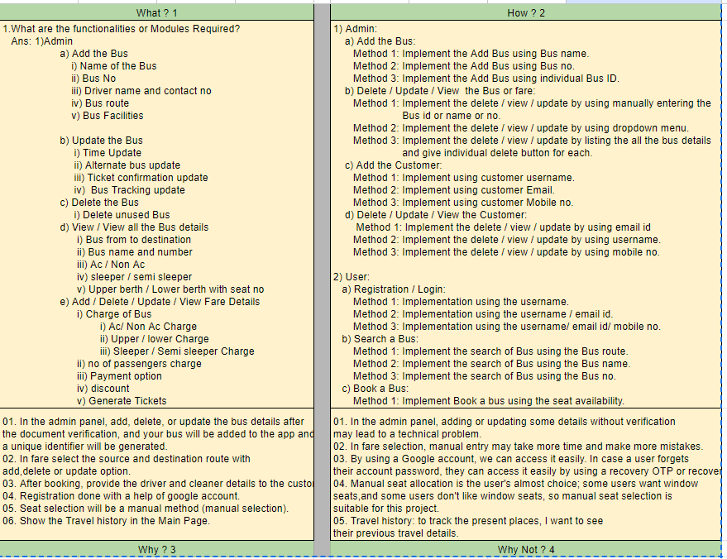

**Admin Algorithm :**

**Admin point of view :**

**Step 01:** Start

**Step 02:** Create an admin panel(lOGIN PAGE).

**Step 03:**  Check whether the page login. If login,move to step 3. If not, move to step 8.

**Step 04:** Verify the bus documents

**Step 05:** Add the bus details, Delete the bus details, Update the bus details and View the details by using an individual bus id.

**Step 06:** Add the bus route, Update the bus route, Delete the bus route after adding bus details.

**Step 07:**Admin can Add the customer details, Update the customer details, Delete the customer details .

**Step 08** Add the driver and cleaner details, Update the driver and cleaner details, Delete the driver and cleaner details.

**Step 09:** stop

**Admin Flowchart:**

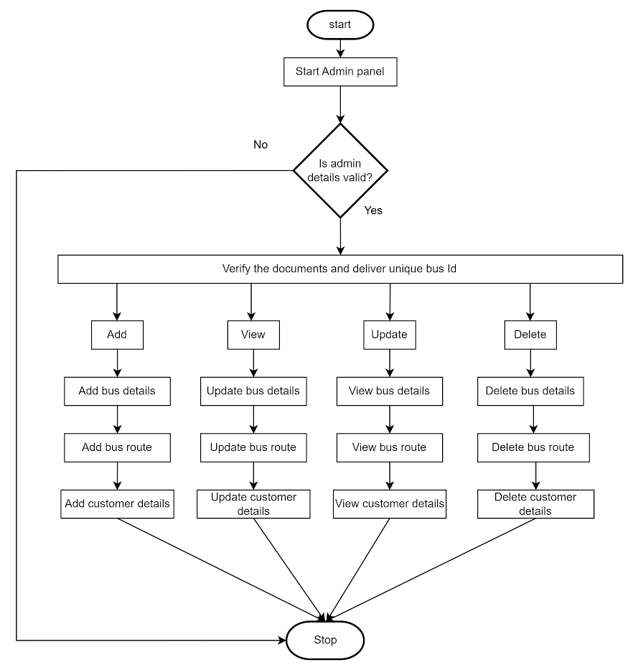

**User Algorithm:**

**Step 01 :** Start.

**Step 02 :** A new user must register his details in the registration form.

**Step 03 :** After registration login to the application by using user id and password.

**Step 04 :** If the user id or password is incorrect then repeat this **step 03** again.

**Step 05 :** User id or password is valid goto the next step.

**Step 06 :** Select the source and destination route.

**Step 07 :** Show the Available seats.

**Step 08 :** Book the seats.

**Step 08 :** Pay the amount for booking.

**Step 09 :** Get the ticket from the application.

**User Flowchart:**

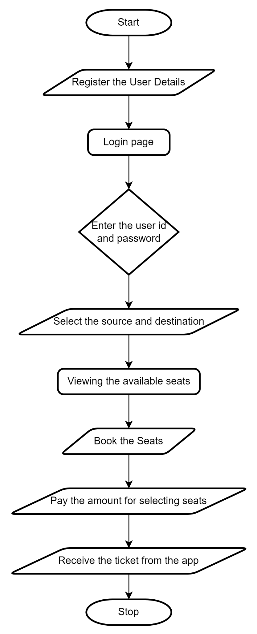

**UML:**

**Admin:**

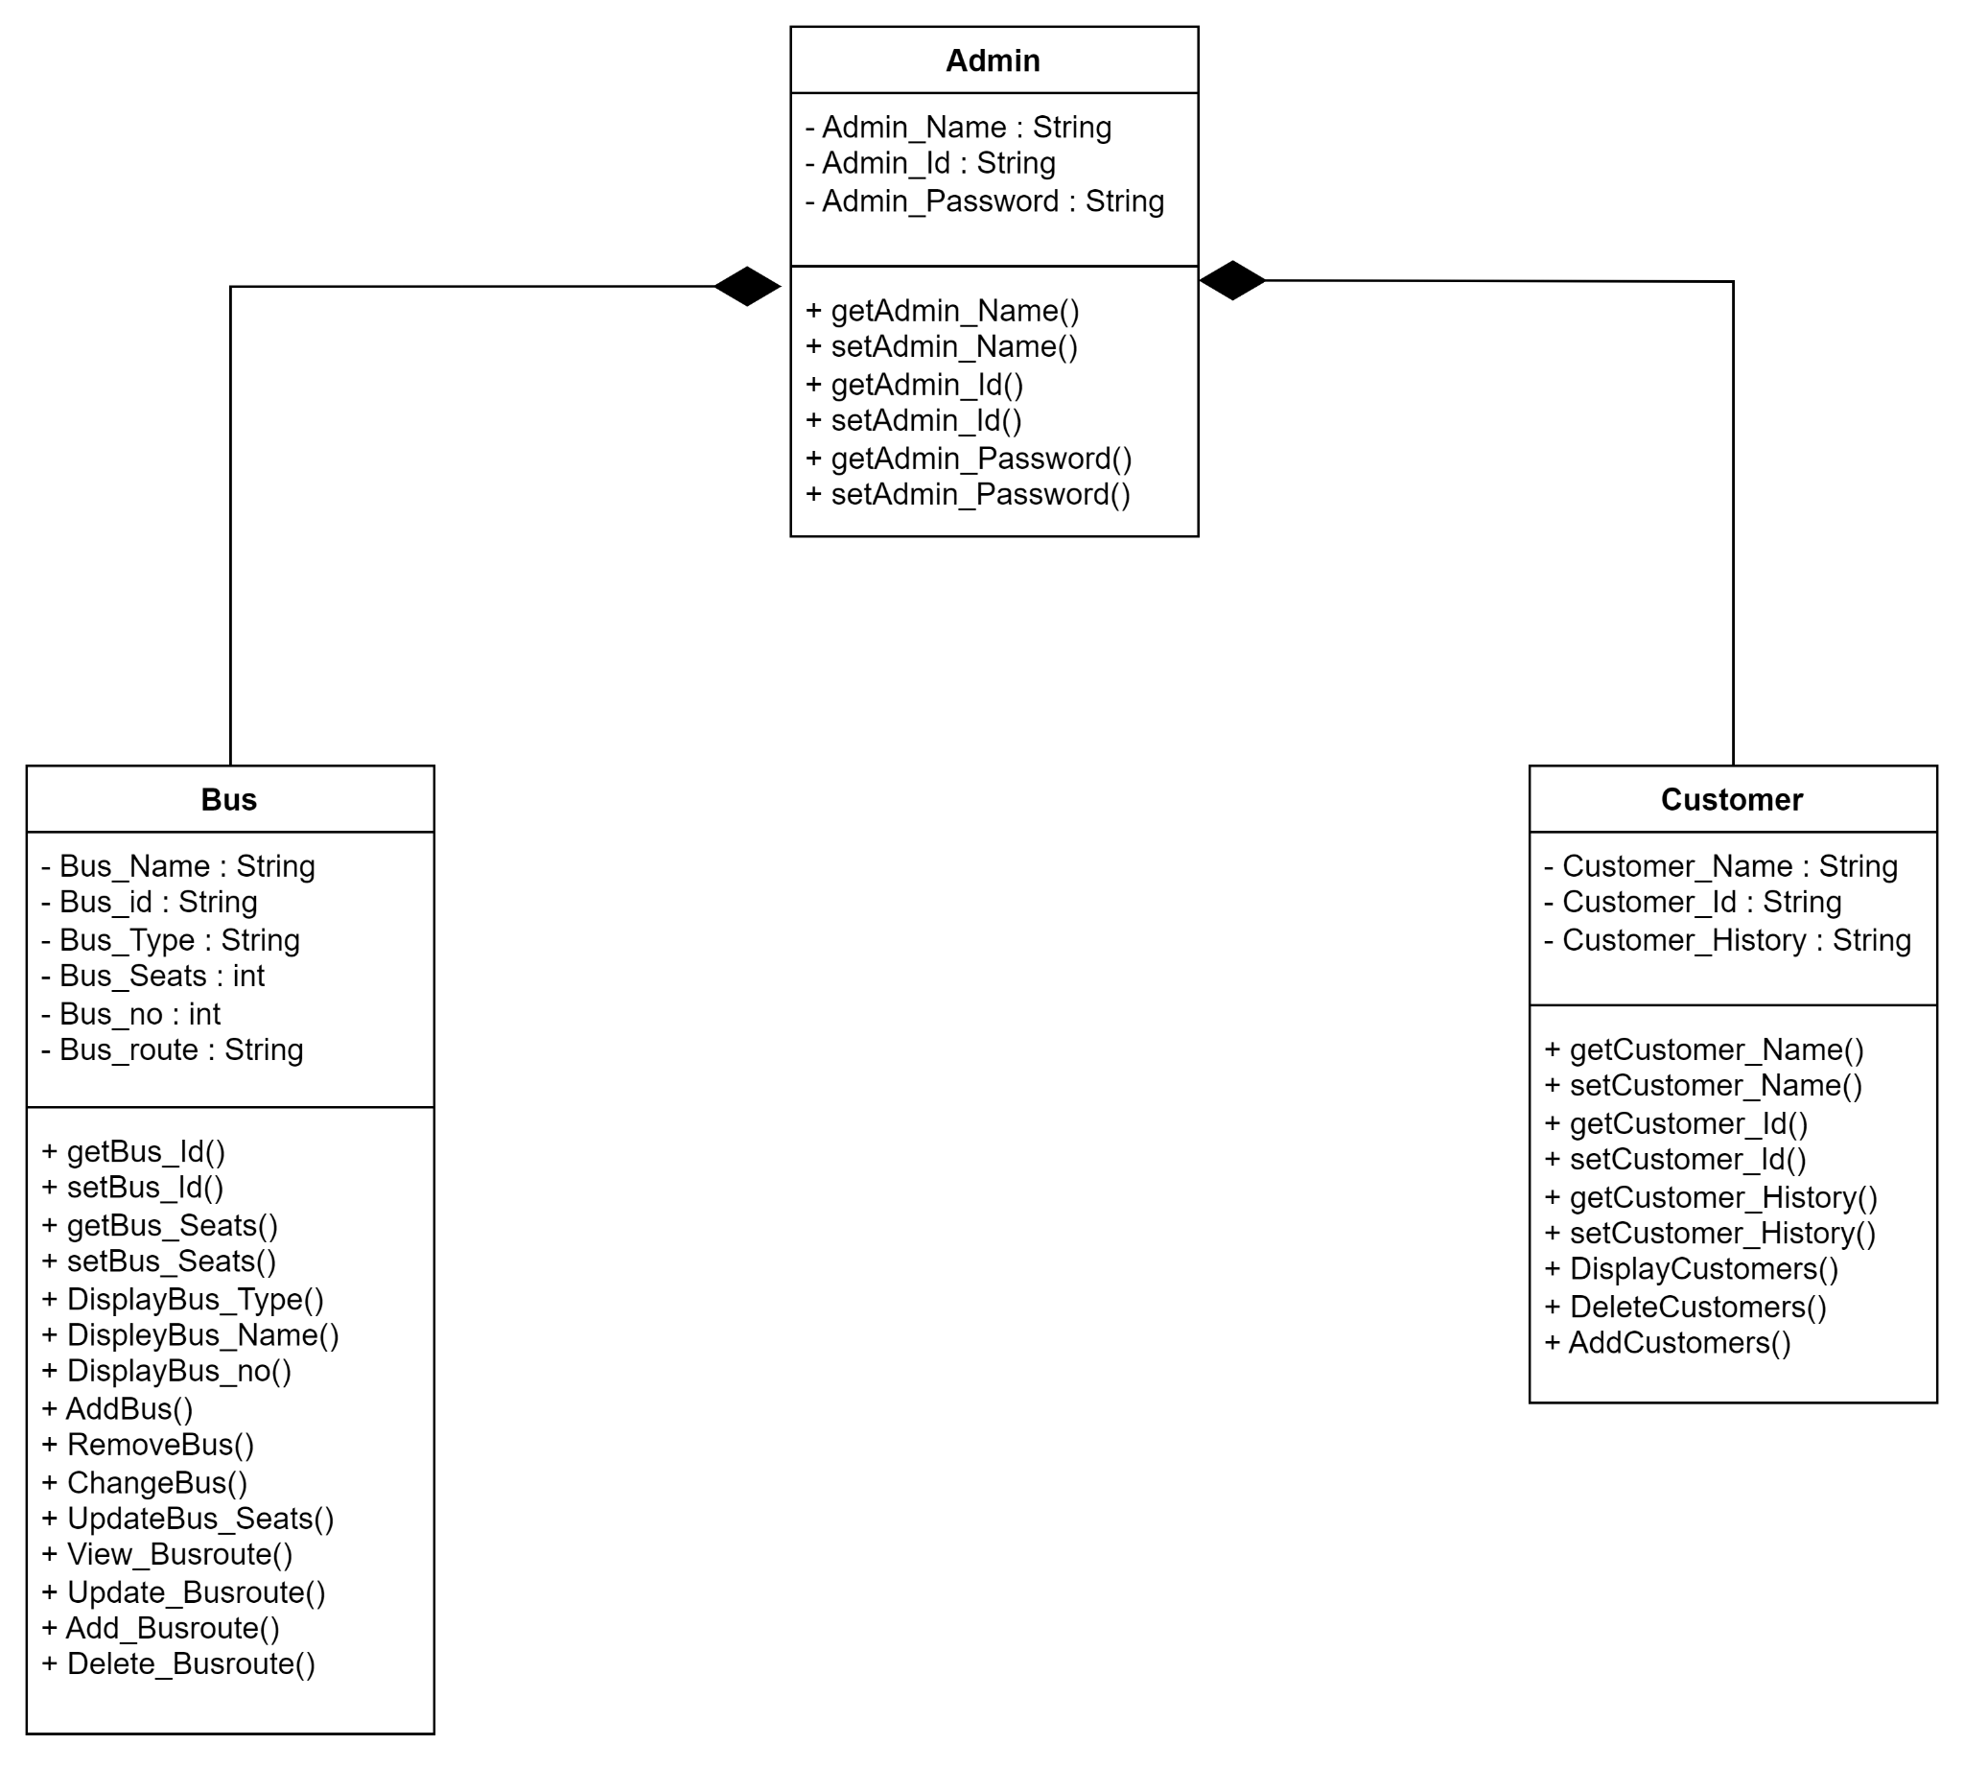

**User:**

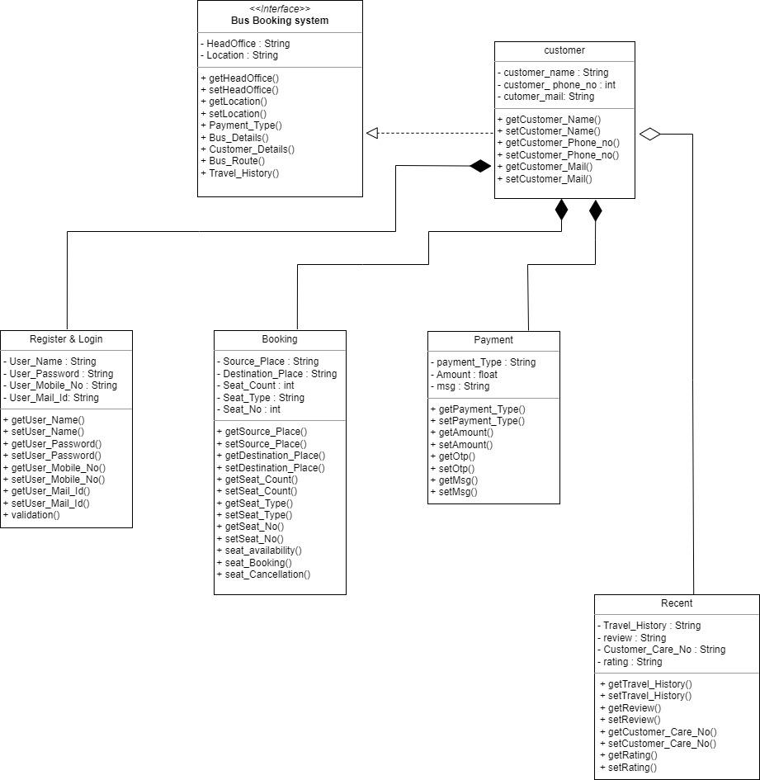

**USE CASE DIAGRAM :**

**ADMIN :**

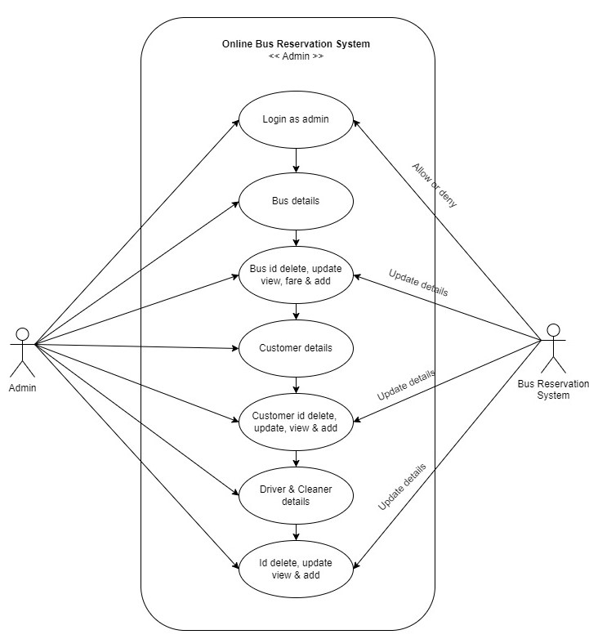

**USER:**

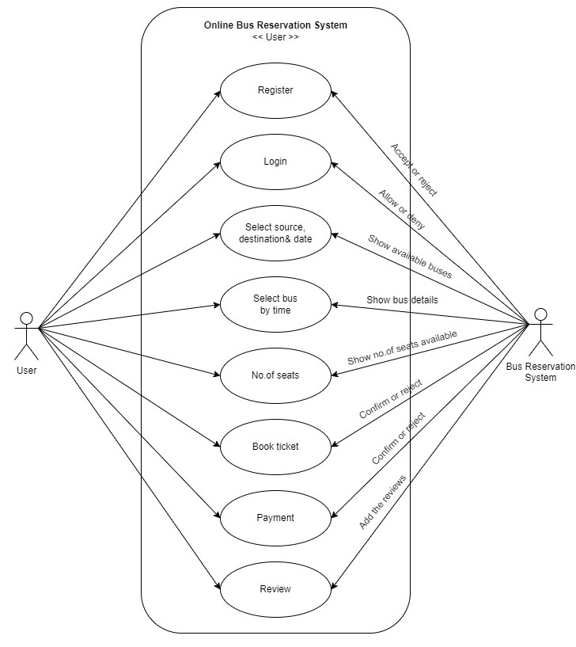

**SEQUENCE DIAGRAM :**

**Register & Login :**

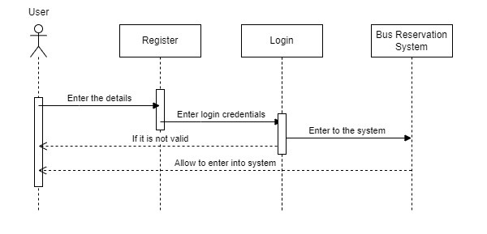

**Bus Fare :**

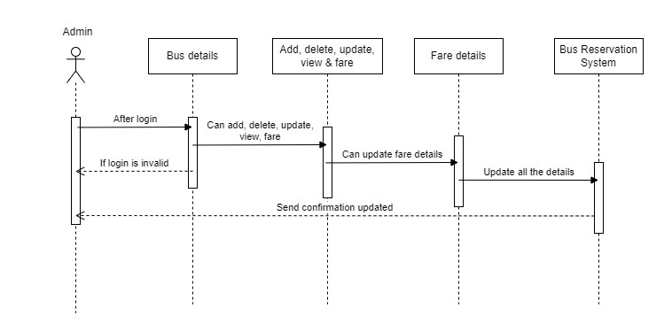

**Customer Details :**

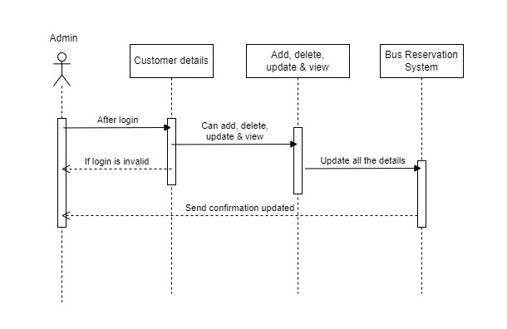

**Driver & Cleaner Details :**

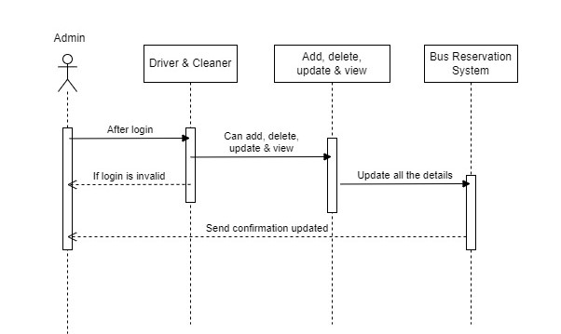

**Booking :**

